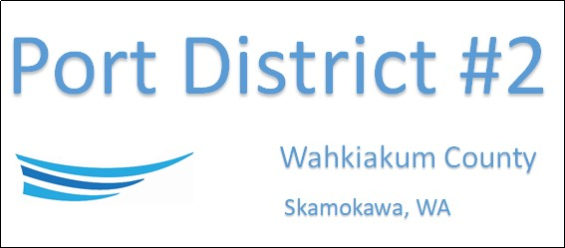

REGULAR BUSINESS MEETING
May 17th, 2022
AGENDA

- Convene/Pledge of Allegiance
- Public Comments
- Ken Johnson-Wahkiakum West

- Old Business

- New Business
- Approve Minutes of April 19th, 2022 meeting
- Approve Vouchers dated thru April 30th, 2022
- Resolution 2022-05 Approving Interim Manger Salary
- Resolution 2022-06 Approving Interlocal with Wahkiakum County for Shared Use of Vendor List and Small Works Roster
- Resolution 2022-07 Adopting Event Center Rental Requirements & Information Policies

- Manager Comments & Updates
- Repairs to Drinking water system
- Grounds Maintenance at Svenson Boat Launch

5. Legal

- Commissioner Comments

- Executive Session
- Qualifications of an applicant for public employment RCW 42.30.110(1)(g)

NEXT MEETING June 21st, 2022 at 5:00 PM
This Meeting Conducted Remotely By Zoom:
Meeting ID 984 096 8115, Password 440554

