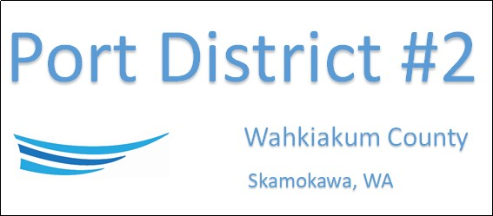

REGULAR BUSINESS MEETING
March 15th, 2022

AGENDA

- Convene/Pledge of Allegiance
- Public Comments

- New Business
- Approve Minutes of February 15th, 2022
- Approve Vouchers dated thru February 28th, 2022
- Resolution 2022-03 Appoint Interim Manager
- Resolution 2022-04 Repeal MRSC Roster

- Manager Comments & Updates
- Church Roof Discussion
- Office repairs and Painting
- Church and Park Electrical Update

5. Legal

6. Commissioner Comments

NEXT MEETING April 19th, 2022 at 5:00 PM

This Meeting Conducted Remotely By Zoom:
Meeting ID 984 096 8115, Password 440554

