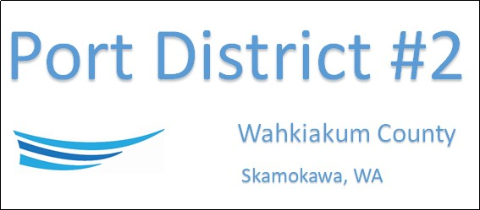

SPECIAL MEETING
May 27th, 2022 at 11 AM
AGENDA

- Convene/Call Meeting to Order

- Executive Session
- Qualifications of an applicant for public employment RCW 42.30.110(1)(g)

NEXT MEETING June 21st, 2022 at 5:00 PM
This Meeting Conducted Remotely By Zoom:
Meeting ID 984 096 8115, Password 440554

