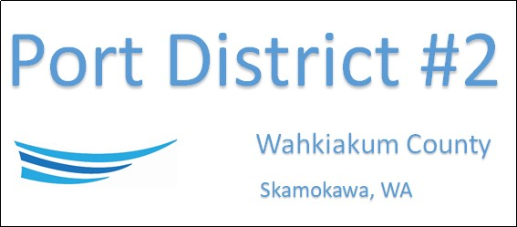

REGULAR BUSINESS MEETING
JUNE 21st, 2022

AGENDA

- Convene/Pledge of Allegiance
- Public Comments
- Old Business
- Naming Former Church Building
- Church Roof Bid
- New Business
- Approve Minutes of May 17th, 2022
- Approve Minutes for May 23rd, May 27th & June 7^{th,} 2022, Special Meeting Minutes
- Approve Vouchers dated thru May 31st, 2022
- Resolution 2022-08, Designating Signatories Concerning The District’s Financial Accounts
- Resolution 2022-09, Appointing new Port Manager
- Manager Comments & Updates
- Office Painting
6. Legal
7. Commissioner Comments

NEXT MEETING July 19th, 2022 at 5:00 PM

This Meeting Conducted Remotely By Zoom:
Meeting ID 984 096 8115, Password 440554

