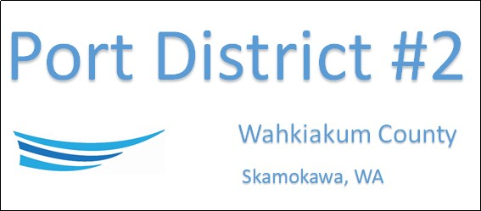

REGULAR BUSINESS MEETING
July 16th, 2024

AGENDA
- Convene/Pledge of Allegiance
- Public Comments
- Old Business
- New Business
  - Approve Minutes of June 18th, 2024 meeting
  - Approve Vouchers dated through June 30th, 2024
  - Commissioner Special Meeting Compensation waiver
- Assistant Port Manager - Vista Park Comments & Updates
  - General Comments
- Port Manager Comments & Updates
  - General Comments
- Legal
- Commissioner Comments
- Executive Session: Performance of a public employee. RCW 42.30.110(1)(g).

NEXT MEETING,
August 20th, 2024 at 3:30 PM
This Meeting Conducted Remotely via Zoom:
Meeting ID 984 096 8115, Password 440554

