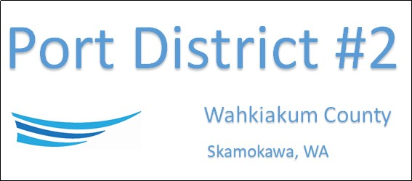

SPECIAL MEETING
APRIL 1ST, 2024
AGENDA
- Open Meeting
- Nomination of Commissioner for Port District #2
- Close Meeting

This Meeting Conducted Remotely via Zoom:
Meeting ID 984 096 8115, Password 440554

NEXT REGULAR BUSINESS MEETING April 16th, 2024, at 3:30 PM

