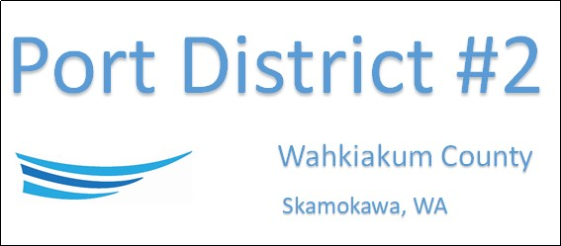

REGULAR BUSINESS MEETING
May 21st, 2024
AGENDA
1. Convene/Pledge of Allegiance
2. Public Comments
3. Regular Monthly Meeting of the Port Commission
a) Old Business
b) New Business
i) Approve Minutes of April 16th, 2024, Meeting
ii) Approve Vouchers dated through April 30th, 2024.
iii) Approve Resolution 2024-04, Appointing Auditor of the District
iv) Approval of Agreement with ADP for payroll service
v) Approval of Resolution 2024-05, Authorizing Manager and Attorney to act as Representatives for RCO Grant
c) Assistant Port Manager - Vista Park Comments & Updates
d) Port Manager Comments & Updates
e) Legal
f) Commissioner Comment

NEXT MEETING June 18th, 2024, at 3:30 PM
This Meeting Conducted Remotely via Zoom:
Meeting ID 984 096 8115, Password 440554

