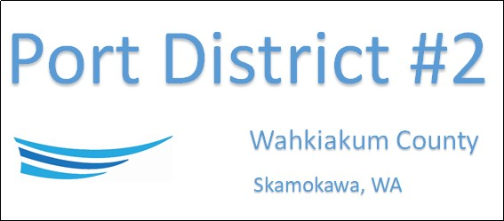

REGULAR BUSINESS MEETING
September 17th, 2024
AGENDA
- Convene/Pledge of Allegiance
- Public Comments
- Regular Monthly Meeting of the Port Commission
  - Old Business
  - New Business
    - Approve Minutes of August 20th, 2024, Meeting
    - Approve Vouchers dated thru August 31st, 2024
    - Approve payment to Wahkiakum County Treasurer in the amount of $11,502.07 for interest owed on current loans
    - Recommend Commissioner for advertising purposes
  - Manager Comments & Updates
    - Kite Festival
    - Vista Park office hours (winter months)
    - Vista Park day use hours
    - Coffee Pot Island Dredging
  - Legal
  - Commissioner Comments

NEXT MEETING October 15th, 2024, at 3:30 PM
This Meeting Conducted Remotely via Zoom:
Meeting ID 984 096 8115, Password 440554

