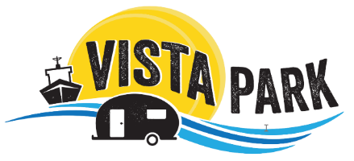
Skamokawa Vista Park Booking Guidelines
- All reservations require a credit card to hold your reservation. Credit Cards will not be charged until guests check- in.
- All Guest must check-in at Parks office or with Park host if office is closed.
- Full Payment for stay is due within 24 hours of arrival or credit card on file will be charged.
- Cancellations for an RV site, Tent site or Yurt within 7 days of scheduled arrival will be charged a 1-night stay. There is no charge outside of the 7 days. Any Holiday weekend cancellation made with in 48 hours of arrival will be charged entire 3 day weekend (Memorial day & Labor day)
- Cancellations for the Cabin within 14 days of arrival will be charged for a 1-night stay. There is no charge outside of 14 days.
- NO CALL/ NO SHOWS reservations for Cabin, Yurts, Tent, or RV site will be charged for full amount of reserved stay.
- Memorial Day and Labor Day weekend reservations require a 3-night minimum stay to book.
- Shelter Rentals are not available online so please call our office to reserve.
- Once payment is received there will be no refunds.
- Each RV site facilitates 1 RV, 1 vechial and 1 tent, each Tent sites facilitates 2 tent and 1 car. Extra cars are $5 per night & extra tents are $10 per night.

