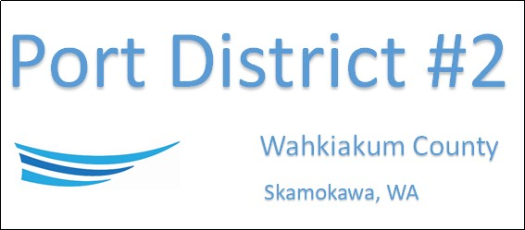

REGULAR BUSINESS MEETING
October 15th, 2024
AGENDA
- Convene/Pledge of Allegiance
- Public Comments

- Old Business

- New Business
- Appoint Commissioner for Position 1
- Approve Minutes of September 17th, 2024, Meeting
- Approve Vouchers dated through September 30th, 2024
- Rate and Budget Hearing – Public Comment

- Manager Comments & Updates

- Legal

- Commissioner Comments

NEXT MEETING November 19th, 2024, at 3:30 PM
This Meeting Conducted Remotely via Zoom:
Meeting ID 984 096 8115, Password 440554

