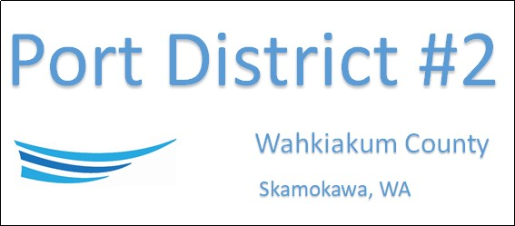

REGULAR BUSINESS MEETING
November 19th, 2024
AGENDA
- Convene/Pledge of Allegiance
- Public Comments

- Old Business

- New Business
- Approve Minutes of October 15th, 2024, Meeting
- Approve Vouchers dated through October 31st, 2024
- Resolution No. 2024-13, Authorizing the 2025 Rate Schedule of the District
- Resolution No. 2024-14, Adopting the 2025 Budget of the District
- Resolution No. 2024-15, 2025 Tax Levy Increase of the District

- Manager Comments & Updates

- Legal

- Commissioner Comments

NEXT MEETING December 17th, 2024, at 2:00 PM
This Meeting Conducted Remotely via Zoom:
Meeting ID 984 096 8115, Password 440554

