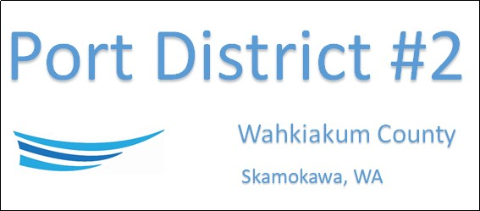

REGULAR BUSINESS MEETING
January 21st, 2025
AGENDA
- Convene/Pledge of Allegiance
- Public Comments
  - Diana Zimmerman, Health & Human Services, National Mentoring Month

- Old Business

- New Business
  - Approve Meeting Minutes of December 17th, 2024
  - Approve Vouchers dated through December 31st, 2024
  - Resolution No. 2025-01, Compensation for the Manager

- Manager Comments & Updates

- Legal

- Commissioner Comments

NEXT MEETING February 18th, 2025, at 2:00 PM
This Meeting Conducted Remotely via Zoom:
Meeting ID 984 096 8115, Password 440554

