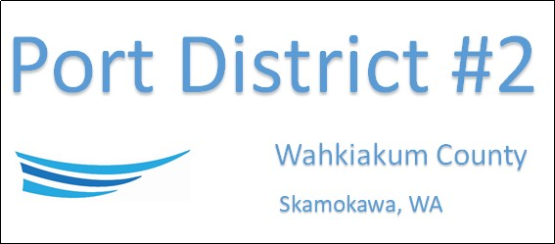

REGULAR BUSINESS MEETING
February 18th, 2025
AGENDA
- Convene/Pledge of Allegiance
- Public Comments

- Old Business

- New Business
  - Approve Meeting Minutes of January 21st, 2025
  - Approve Vouchers dated through January 31st, 2025

- Manager Comments & Updates
  - CWCOG membership renewal

- Legal

- Commissioner Comments

NEXT MEETING March 18th, 2025, at 2:00 PM
This Meeting Conducted Remotely via Zoom:
Meeting ID 984 096 8115, Password 440554

