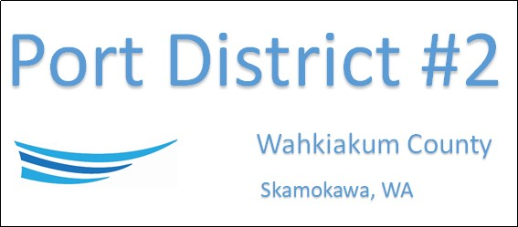

REGULAR BUSINESS MEETING
March 18th, 2025
AGENDA
- Convene/Pledge of Allegiance
- Public Comments
  - Columbia Coast TV Show- Ken Johnson
- Old Business
- New Business
  - Approve Meeting Minutes of February 18th, 2025
  - Approve Vouchers dated through February 28th, 2025
- Manager Comments & Updates
  - Wholesale Ice Price
  - Surplus wooden boat
  - Rebranding Vista Park-website and logo
  - Svenson Park host discussion
- Legal
- Commissioner Comments

NEXT MEETING April 15th, 2025, at 2:00 PM
This Meeting Conducted Remotely via Zoom:
Meeting ID 984 096 8115, Password 440554

