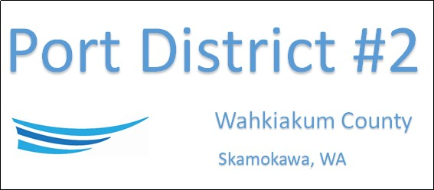

REGULAR BUSINESS MEETING
April 15th, 2025
AGENDA
- Convene/Pledge of Allegiance
- Public Comments
- Old Business
- New Business
  - Approve Meeting Minutes of March 18th, 2025
  - Approve Vouchers dated through March 31st, 2025
- Manager Comments & Updates
- Legal
- Commissioner Comments

NEXT MEETING May 20th, 2025, at 2:00 PM
This Meeting Conducted Remotely via Zoom:
Meeting ID 984 096 8115, Password 440554

