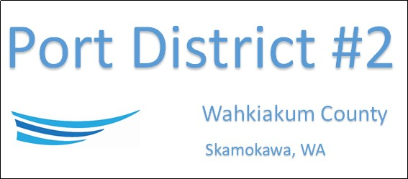

REGULAR BUSINESS MEETING
May 20th, 2025
AGENDA
- Convene/Pledge of Allegiance

- Public Comments

- Old Business

- New Business
  - Approve Meeting Minutes of April 22nd, 2025
  - Approve Vouchers dated through April 30th, 2025
  - Nomination of Potential Commissioner

- Manager’s Comments & Updates

- Legal

- Commissioner Comments

NEXT MEETING June 17th, 2025, at 2:00 PM
This Meeting Conducted Remotely via Zoom:
Meeting ID 984 096 8115, Password 440554

