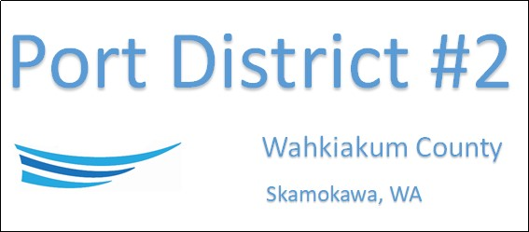

REGULAR BUSINESS MEETING
August 19th, 2025
AGENDA
- Convene/Pledge of Allegiance
- Public Comments
- Old Business
- New Business
  - Approve Meeting Minutes of July 15th, 2025
  - Approve Vouchers dated through July 31st, 2025
  - Purchase of new Port truck - New vs Used
- Manager’s Comments & Updates
- Legal
- Commissioner Comments
- Executive Session
  - Real estate sale, purchase, or lease if a likelihood that disclosure would increase price. RWW 42.30.110(1)(b),(c). If agency is seller/lessor, only minimum price may be discussed & factors influencing price must be discussed in public session.

NEXT MEETING September 16th, 2025, at 2:00 PM
This Meeting Conducted Remotely via Zoom:
Meeting ID 984 096 8115, Password 440554

