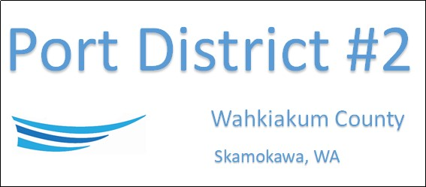

REGULAR BUSINESS MEETING
November 19th, 2025
AGENDA
- Convene/Pledge of Allegiance
- Public Comments
- Old Business
  - Website and Branding
- New Business
  - Approve Meeting Minutes of October 21st, 2025
  - Approve Vouchers dated through October 31st, 2025
  - Resolution 2025-04, Adopting the 2026 Budget of the District
  - Resolution 2025-05, Tax Increase of the District
  - Resolution 2025-06, Authorizing the 2026 Rate Schedule of the District
  - Resolution 2025-07, Delegation of Authority
- Manager’s Comments & Updates
- Legal
- Commissioner Comments
- Executive Session: Performance of a public employee. RCW 42.30.110(1)(g)

NEXT MEETING December 16th, 2025, at 2:00 PM
This Meeting Conducted Remotely via Zoom:
Meeting ID 984 096 8115, Password 440554

