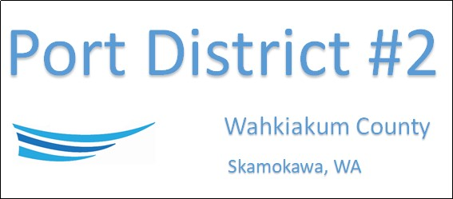

REGULAR BUSINESS MEETING
December 16th, 2025
AGENDA
- Convene/Pledge of Allegiance
- Public Comments
- Old Business
- New Business
  - Approve Meeting Minutes of November 18th, 2025
  - Approve Vouchers dated through November 30th, 2025
  - Resolution 2025-08, Authorizing an increase in the Compensation of the Manager
  - 2026 Board Reorganization
- Manager’s Comments & Updates
- Legal
- Commissioner Comments

NEXT MEETING January 20th, 2026, at 2:00 PM
This Meeting Conducted Remotely via Zoom:
Meeting ID 984 096 8115, Password 440554

