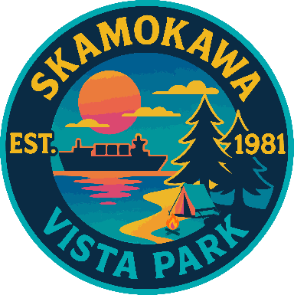

REGULAR BUSINESS MEETING
April 21st, 2026
AGENDA

- Convene/Pledge of Allegiance
- Public Comments
- Old Business
  - Overtime policy suggestions
- New Business
  - Approve Meeting Minutes of March 17th, 2026
  - Approve Vouchers dated through March 31st, 2026
- Manager’s Comments & Updates
- Commissioner Comments

NEXT MEETING May 19th, 2026, at 2:00 PM
This Meeting Conducted Remotely via Zoom:
Meeting ID 984 096 8115, Password 440554

